Homework 1 – Joris Chomarat

**Problem 1**

**Problem 2**

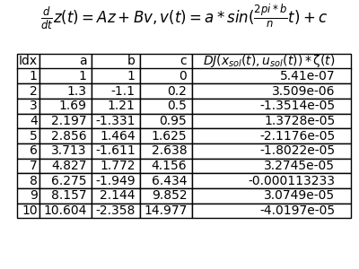**Problem 3**